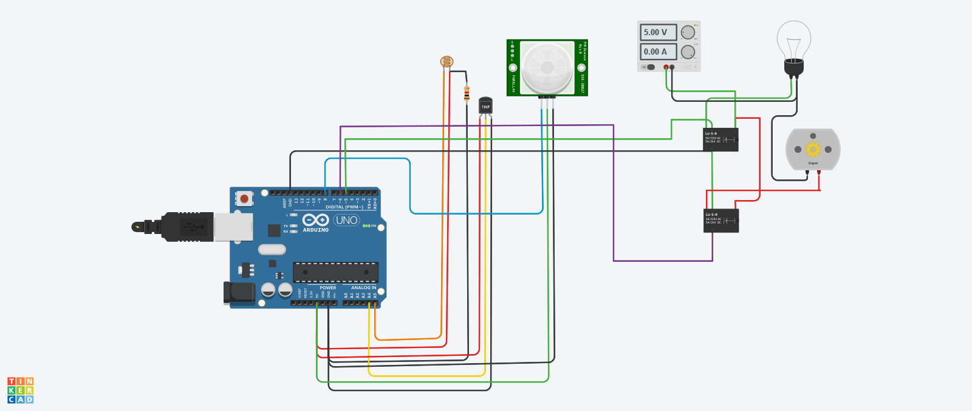

float x,y,z,temp;

void setup()

{

pinMode(8, INPUT);

pinMode(5, OUTPUT);

pinMode(6, OUTPUT);

pinMode(A5, INPUT);

pinMode(A4, INPUT);

Serial.begin(9600);

}

void loop()

{

x= digitalRead(8);

y= analogRead(A5);

z= analogRead(A4);

Serial.println(x);

Serial.println(y);

Serial.println(z);

temp = (double)z / 1024;

temp = temp - 5;

temp = temp - 0.5;

temp = temp - 100;

if ( (x>0) )

{

if ((y<550)&&(temp>30))

{

digitalWrite(5, HIGH);

digitalWrite(6, HIGH);

}

else if((y<550)&&(temp<30))

{

digitalWrite(5, HIGH);

digitalWrite(6, LOW);

}

else if((y>550)&&(temp>30))

{

digitalWrite(5, LOW);

digitalWrite(6, HIGH);

}

else if((y>550)&&(temp<30))

{

digitalWrite(5, LOW);

digitalWrite(6, LOW);

}

}

else

{

digitalWrite(5, LOW);

digitalWrite(6, LOW);

}

}